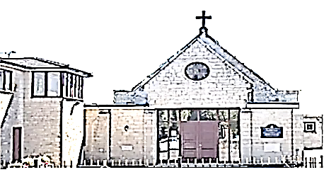 | St Joseph’s Church  (Clifton Diocese)
Devizes Road, Wroughton, Swindon, SN4 0RZ, Tel: 01793 812 330, Email: wroughton.stjoseph@cliftondiocese.com
APPLICATION FOR BAPTISM
Surname of Child Forename(s) .
Date of Birth Place .
Full Name of Father Religion .
Full Name of Mother nee Religion .
Address .
Telephone Number .
Full Name of Godfather Religion .
Full Name of Godmother Religion .
NB: Either Godfather or Godmother must be a practicing Catholic
DATE AND TIME OF BAPTISM (To be agreed with Fr. Nnam Di Obi) .
To be baptised is to:
- Become a Child of God
- Become a Member of the Church of Christ
- Share in the Death and Resurrection of Christ
- Become a Template of the Holy Spirit

This involves the serious undertaking to lead a life of attachment to our Lord Jesus Christ. Hence, the parents of the child are asked to answer the following questions:
- Do you realise that in asking to have your child baptised, you accept the duty of raising him/her in the faith of the Catholic Church, so that by observing the commandments, he/she will love in God and neighbour as Christ taught us?

Answer .

Will you fulfil this duty by word and example? Answer .

- We/I declare that we/I understand the meaning, the privileges and the duties of baptism.
We/I undertake the serious obligation to bring our child to Mass each week and give him/her a Catholic education.
We/I have answered the questions truthfully before God.
Signatures [Father]*

[Mother]*
In the case of a “mixed” marriage the partner who belongs to another Christian Community may wish to give the same undertaking. If not, he/she is asked to make the following declaration:
I willingly allow my child to be baptised according to the rite and teaching of the Catholic Church.
Signature .
If the child’s parents reside of the parish boundaries, the local Parish Priest must give his permission:
I, Parish Priest of __________________ hereby give permission for the child to be baptised in the parish of St. Joseph’s, Wroughton.
Signature Date .
Information provided on this form, together with all other personal data held about individuals by the parish and the Clifton Diocese, is processed in accordance with the Diocese’s Privacy Policy Notice; which is available at https://cliftondiocese.com/privacy-notice or from the parish.

